Lab 2: Process Monitoring – Check if a Process is Running
In a DevOps environment, it's important to monitor processes or services and ensure they are running as expected. Shell scripts can help automate this by checking for processes and taking action if they're not found.
In this lab, you will create a script that checks whether a given process (by name) is running on the system. Such checks are useful in health monitoring scripts and cron jobs to restart critical services if they crash.

Learning Objectives
· Learn to use the pgrep command to search for processes by name.
· Understand how to use exit status of commands (success or failure) in an if...then...else shell structure.
· Use shell variables to easily change which process to monitor.
· Practice printing informative messages for both outcomes (running or not running).

Step-by-Step Instructions
1. Choose a Target Process: Decide on a process name to check.
For example, use a basic system service like "cron" (the scheduler) or "sshd" (SSH daemon) if available.
Ensure the process is one that might be running on your system (you can list running processes with ps -e or top).
2. Create the Script File: Open a new file check_process.sh in your editor.
3. Write the Script Content: Copy the script below. It defines a process name to look for and uses pgrep to determine if such a process is active. The script then prints a message indicating the status. Comments explain each part.
4. Save and Make Executable: Save the file and run chmod +x check_process.sh to give it execute permission.
5. Run the Script: Execute it with ./check_process.sh. By default, it will check for "cron". If the process is running, you’ll see a message that it is running; if not, you’ll see it is NOT running. Try changing the process variable in the script (e.g., to "bash" or a fictitious name) and run again to see both outcomes.
6. Real-world Use: Think about how this could be used in practice. For example, you could extend this script to automatically start the process if it’s not running, or schedule this script to run via cron for continuous monitoring (covered in Lab 5).

Shell Script: check_process.sh
#!/bin/bash
# Lab 2: Process Monitoring
# This script checks if a given process is running and reports its status.
process="cron" # Name of the process to check (change this as needed)
# Use pgrep to search for the process by name.
# -x ensures an exact match (e.g., "cron" won't match "crond").
if pgrep -x "$process" > /dev/null; then
echo "$process is running"
else
echo "$process is NOT running"
fi
Script Explanation:
We set a variable process to the target process name.
The pgrep -x "$process" command searches running processes for an exact name match. We redirect its output to /dev/null because we only care about the command's exit status (we don't need to see the list of processes in this case).
In the if statement, when the process is found, pgrep exits with status 0 (success), so the script prints "cron is running". If pgrep doesn’t find a match, it exits with a non-zero status, and the script prints that the process is not running.
This simple pattern can be expanded for multiple processes or to trigger alerts/restarts. (For example, such a check is “useful in health-check scripts, cron jobs, or system monitoring tools.”)

Sample Output
Run the script when the process is running (for instance, "cron" is usually running on Ubuntu):
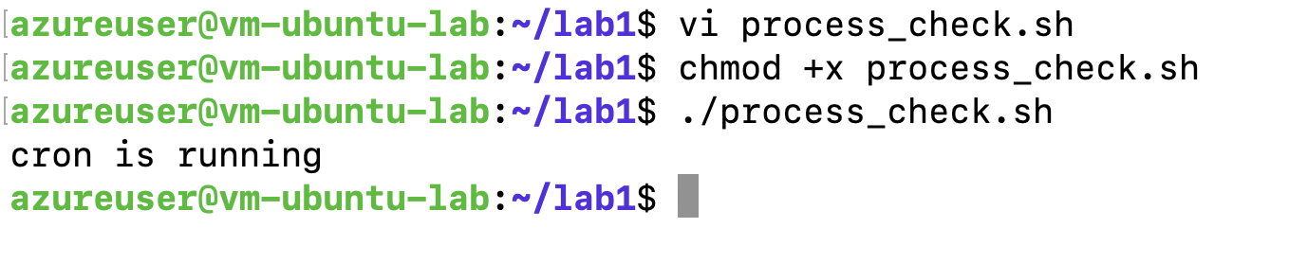
cron is running
If you check a process that isn't running (e.g., set process="fakeproc" or some name you know is not present), you'll get:
fakeproc is NOT running
You can verify by running pgrep -x cron or pgrep -x fakeproc manually.
The script’s output will change according to the process’s status.
In real scenarios, you might integrate this with email alerts or service restarts.
For now, you’ve learned how to programmatically detect process presence using a shell script, which is a foundational skill in process monitoring.

